**SQL Task**

1. **Aim: Design and Develop SQL DDL statements which demonstrate the use of SQL objects such as Table, View, Index, Sequence, Synonym Problem Statement:**

**1. Create table Customers with schema (cust_id, cust_name, product, quantity, total_price)**



**2. Use sequence/ auto-increment for incrementing customer ID and Insert 5 customer records to the table Customers**

Note : Can’t apply auto-increment to already created column



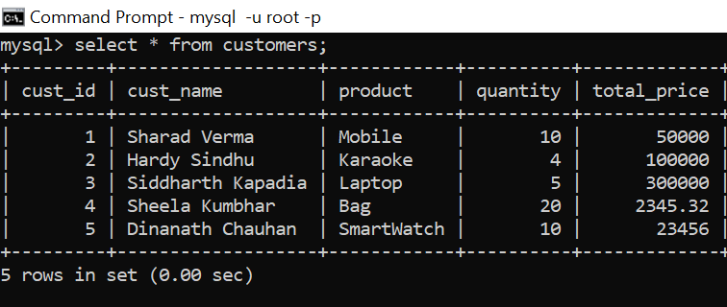

**3. Alter the table Customers by adding one column 'price_per_qnty’**



**4. Create view 'Cust_View’ on Customers displaying customer ID, customer name**



**5. Update the view 'Cust_View' to display customer ID, product, total price**



**6. Drop the view 'Cust_View'**

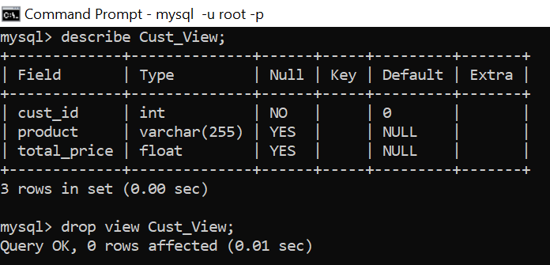

**7. Create index 'Cust index' on customer name**

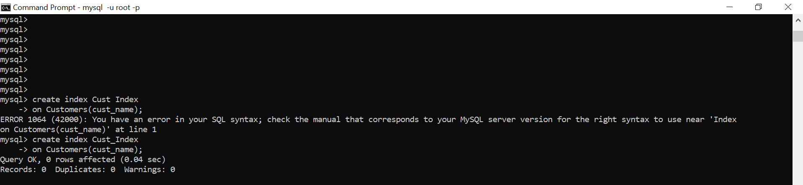

**8. Drop index 'Cust_index'**



**9. Use sequence/ auto-increment for incrementing customer ID**

Note : The question has already been answered in question 2

**10. Use the name alias for table Customers (rename the table in query)**



**11. Drop the table Customers**



1. **For facebook user, make sure only age>=18 users can able to register in table.**

**1) Table created:**

mysql> create table user(id int NOT NULL,firstname varchar(255),lastname varchar(255),city varchar(255),age int check(age>=18));

Query OK, 0 rows affected (0.04 sec)

mysql> describe user;

+----------+--------------+------+-----+---------+-------+

| Field | Type | Null | Key | Default | Extra |

+----------+--------------+------+-----+---------+-------+

| id | int | NO | | NULL | |

| firstname | varchar(255) | YES | | NULL | |

| lastname | varchar(255) | YES | | NULL | |

| city | varchar(255) | YES | | NULL | |

| age | int | YES | | NULL | |

+----------+--------------+------+-----+---------+-------+

5 rows in set (0.01 sec)

**2) age > 18 checked:**

mysql> insert into user values(1,"Swaraj","Kokate","Pune",22);

Query OK, 1 row affected (0.01 sec)

**3) age < 18 checked:**

mysql> insert into user values(2,"Siddhesh","Kokate","Pune",17);

ERROR 3819 (HY000): Check constraint 'user_chk_1' is violated.

1. **age = 18 checked:**

mysql> insert into user values(3,"Mehak","Sharma","Nigdi",18);

Query OK, 1 row affected (0.01 sec)

mysql> insert into user values(4,"Sunita","Raman","Bangalore",19);

Query OK, 1 row affected (0.01 sec)

mysql> insert into user values(5,"Meena","Srivastava","Mumbai",80);

Query OK, 1 row affected (0.01 sec)

1. **Also, age = 0 checked:**

mysql> insert into user values(6,"Sheetal","Choksi","Daman",0);

ERROR 3819 (HY000): Check constraint 'user_chk_1' is violated.

1. **Final table:**

mysql> select * from user;

+----+----------+------------+-----------+------+

| id | firstname | lastname | city | age |

+----+----------+------------+-----------+------+

| 1 | Swaraj | Kokate | Pune | 22 |

| 3 | Mehak | Sharma | Nigdi | 18 |

| 4 | Sunita | Raman | Bangalore | 19 |

| 5 | Meena | Srivastava | Mumbai | 80 |

+----+----------+------------+-----------+------+

4 rows in set (0.00 sec)

**3) Alter - add column email=>”@” & “.” and age >= 18.**

1. **Added email field:**

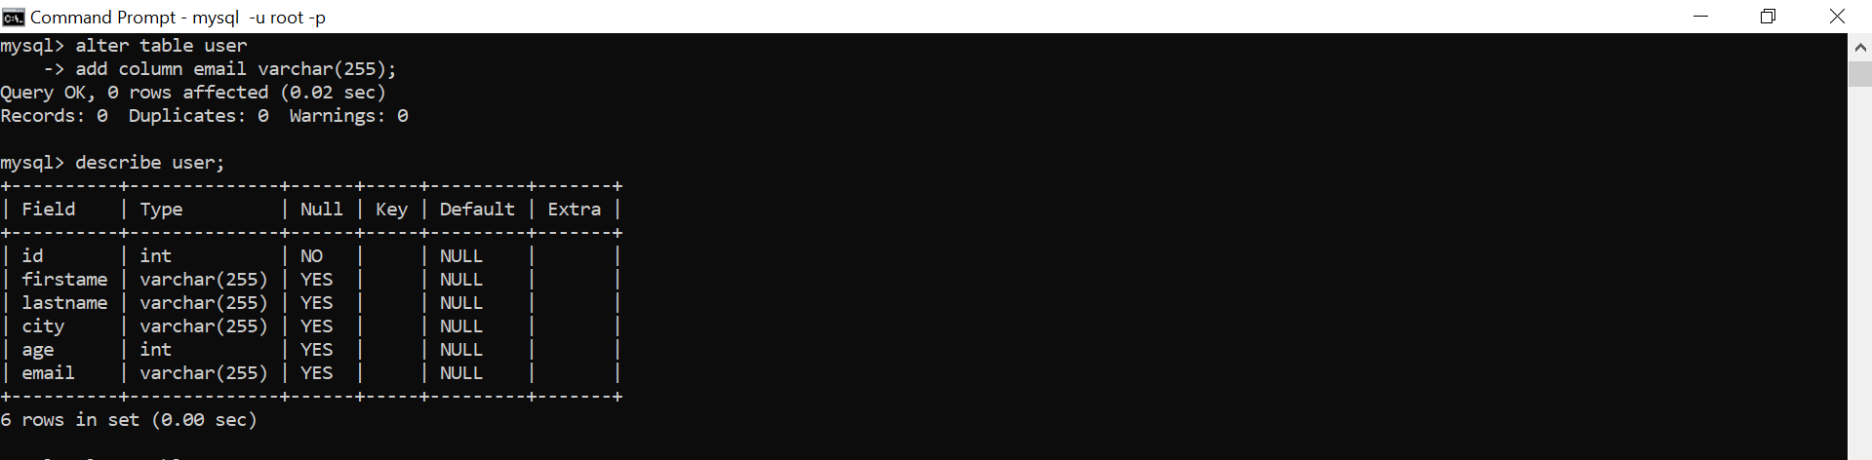

1. **Added the constraint for age and email and inserted query:**

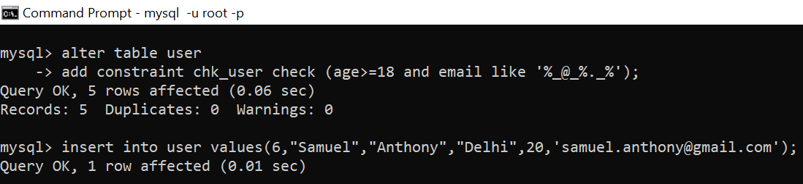

1. **Tested with multiple queries:**

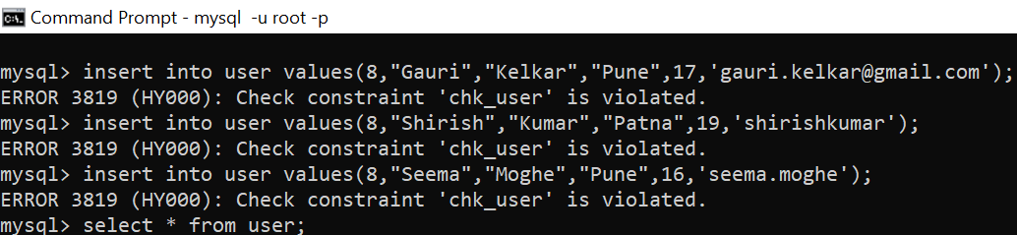

1. **Final table:**

